AUTHORING TOOL DESIGN DOCUMENT

TITLE: RealSim

PROJECT SUMMARY

Building animation tools for fluid-like motion is particularly important, and it is a challenging problem for many applications in computer graphics. Using physics-based models for fluid flow can greatly help create such tools. Compared with keyframe or process-based techniques, physics-based animation simulation enables animators to produce interesting fluid phenomena almost effortlessly. Similarly, it is easy to deal with the flow and interaction with other objects.

In physics-based fluid simulation, many algorithms are involved, and SPH is a calculation method used to simulate the dynamics of continuum media. At the same time SPH has many advantages, including 1) Through construction, SPH is a meshless method, which is very suitable for simulating problems dominated by complex boundary dynamics. 2) The lack of mesh greatly simplifies the realization of the model and its parallelization. 3) SPH guarantees conservation of mass without extra computation because the particles themselves represent mass. 4) SPH calculates pressure by calculating the weighted contribution of neighboring particles, rather than by solving linear equations to calculate pressure. Based on the above characteristics, it is very consistent with our product's requirements for achieving a balance between visual effects and accuracy, that is, it does not require excessive calculation costs to achieve a certain visual effect.

Our authoring tool, Ghost Fluid Simulator, is based on a new and robust algorithm of SPH called Ghost SPH to simulate the water animation. We refer to the paper, Ghost SPH for Animating Water, by Hagit Schechter and Robert Bridson. Compared to the previous SPH, Ghost SPH solved the remaining problem. 1) Mass-conserving SPH methods, where density is estimated by a sum rather than evolved as a state variable, suffer serious errors near free surfaces causing unavoidable surface-tension-like artifacts and reduced stability. 2) Prior treatments of arbitrary solid boundaries do not reflect the correct cohesive behavior visible in many real-world scenarios.

1. AUTHORING TOOL DESIGN

1.1. Significance of Problem or Production/Development Need

In the market, few related products are used for real-time simulation and can be used for large-scale modeling software in Maya and Houdini. We hope that this product can fill the corresponding product blanks well, so that game practitioners and other simulation-related practitioners can more conveniently implement fluid simulation, and at the same time, it can simulate liquids of different properties only by modifying the parameters. Compare with all other current simulators, we found that most of the products are either completely used for engineering simulation, and strive to be completely accurate in physical characteristics, which requires a lot of calculations or sacrifice accurate features to blindly pursue Visual beauty. As a result, it is not possible to fully balance aesthetics and physical accuracy. We hope that our products can achieve this kind of balance, that is, by giving up some of the secondary physical properties, but making them conform to the physical properties while taking into account the visual beauty.

1.2. Technology

- Provide an overview of the Siggraph paper you will be used as the basis for your tool.
- Also include an explanation for why you chose this paper.

In 1997, Gingold and Monaghan [1977] and Lucy introduced the SPH, which makes use of the Lagrangian description of fluid flow which automatically focuses attention on fluid elements. In their paper, they first give a detailed description of the smoothing method and establish conditions that guide the choice of the smoothing kernel. The method of SPH has very advantage, most SPH enjoys automatic mass conservation (each particle represents a fixed amount of conserved mass, density is estimated by direct summation), accurate tracking of the fluid through space (due to the Lagrangian representation), and a conceptually simple algorithmic kernel (summing weighted kernels over nearby particles, with no systems of equations to solve or tricky geometric discretizations). Because of these advantages, it has become extremely popular in computer graphics for a variety of liquid phenomena.

In the paper of Ghost SPH for Animating Water, they solve the above problems by a careful sampling of ghost particles in the air and solid regions near the fluid, and appropriate extrapolation of fluid quantities to the ghost particles.

1.3. Design Goals
Describe how your authoring tool will address the problem or need.

1.3.1 Target Audience.
Graphics related practitioners, technical artists, designers, and game producers

1.3.2 User goals and objectives
Implementing physics-based fluid simulation through the plugin, and implement the collision interaction between fluid and solid, and generate obj file for export.

1.3.3 Tool features and functionality
By adjusting the parameter in UI to change the amount of the particles, the volume of each, and the physical property of the fluid, such as the viscosity, simulate flowing fluid and capture the fluid animation. Then export the file as obj. format.

1.3.4 Tool input and output
the amount of the particles, the volume, and the physical property of the fluid, such as the viscosity, mass, and density.

1.4. User Interface

1.4.1 GUI Components and Layout

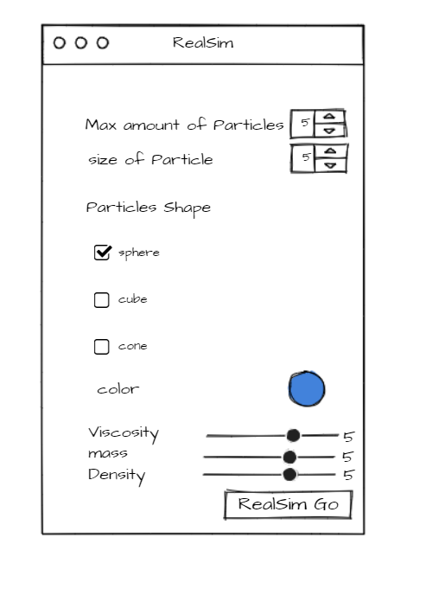

Adjusting the parameter above to modeling the fluid simulation, using the animation components of the Maya to capture the fluid animation, and export the obj. file in file tab.

1.4.2 User Tasks
Selecting the preferred value, including the amount, size, and color of the particles and viscosity in the UI to determine the property of the fluid and click the Realism Go to generate.

1.4.3 Workflow
1. Generate the basic geometry either by the setting of our UI or by the model Maya.
2. select the number of particles, the size of the particle, and the color
3.adjust the viscosity to determine the property of the fluid,
4. add a solid geometry somewhere and generate the fluid.
5. change to the animation component and capture the animation.
6. export via obj format.

2. AUTHORING TOOL DEVELOPMENT

2.1. Technical Approach

2.1.1 Algorithm Details
The algorithm solves the particle deficiency at boundaries and eliminates artifacts by (1) dynamically seeding ghost particles in a layer of air around the liquid with a blue noise distribution, (2) extrapolating the right quantities from the liquid to the air and solid ghost particles to enforce the correct boundary conditions, and (3) using the ghost particles appropriately in summations. Mass, density, and velocity are assigned to ghost particles in the spirit of Fedkiw’s Ghost Fluid Method: if a quantity should be continuous across a boundary, it is left as is in the ghost; if it is decoupled and may jump discontinuously, the fluid’s value is instead extrapolated to the ghost.

2.1.2 Maya or Houdini Interface and Integration
We will implement a Maya node which (1) takes the current polygon in the scene and the current time t as input, (2) consult the C++ OpenGL ghost SPH library to generate the current frame point cloud of liquid pouring (on the polygon) animation based on t, (3) render visible Maya object (presumably polygons or NURBS surface) based on the point cloud data. The logic flow will be similar to the LSystem node that takes polygons as tree components input and generates animation w.r.t. iteration steps.

2.1.3 Software Design and Development
Mesh: A basic mesh data structure that will be used to determine the property of the particle, such as the color, amount, shape, and size of the particle.

Solid polygon: A structure that would be used as the solid object that is in contact with the fluid,

The fluid which is consists of many particles and the viscosity to determine the property of physics.

2.2. Target Platforms

2.2.1 Hardware
Processor: Intel(R) Core (TM) i7-9750H CPU @2.60GHz 2.59GHz
GPU: NVIDIA GeForce GTX 1650

2.2.2 Software
Windows 10
Maya 2020
OpenGL 3.3
Microsoft Visual Studio 2019

2.3. Software Versions

2.3.1 Alpha Version Features (first prototype)
Implement the node in Maya and takes the current polygon in the scene and the current time t as input, to generate the fluid.

2.3.2 Beta Version Features
by C++ OpenGL ghost SPH library to generate the current frame point cloud of liquid pouring (on the polygon) animation based on t, to implement the interaction between the solid and fluid object.

2.3.3 Description of any demos or tutorials
Alpha Version Demo: it would show the implementation of fluid simulation which is based on the parameter given in the UI, and fluid would be pouring down without any contact with other objects.

Beta Version Demo: we will try to implement the simulation of solid and fluid interaction in the Maya.

Final Version Demo: Based on the work of previous versions, we will implement the rendering if there is available time. And export the model in the format of obj. format.

3. WORK PLAN

3.1. Tasks and Subtasks

Task one: Implementation UI dialogs (8 days)
- Implement the draft of UI dialogs in the online UI design APP.
- Implementation of the UI dialogs in Maya using MEL.
- Test the dialogs in Maya.

Task two: Implement the fluid simulation. (10 days)
- Study the paper Ghost SPH for Animating Water, and understand the corresponding algorithm and sampling method.
- Make Maya python node consult the C++ OpenGL ghost SPH library to generate the current frame point cloud of liquid pouring (on the polygon).
- And test the code based on the parameter in the UI.

Task three: Implement the fluid-Solid interaction. (14 days)
- Implement the part of surface sampling in the paper to implement the interaction.
- Implement the part of Surface and Volume Relaxation to reduce noise in the SPH density by optimizing sample locations.
- time step, Mass, density, and velocity are assigned to ghost particles in the spirit of Fedkiw’s Ghost Fluid Method based on the ghost SPH algorithm.

Task Four: implement the testing. (5 days)
- Test the code and user interface from an engineering perspective and optimize it.
- Debugging the code, recording a video, and write the tutorial document
- Preparing for the presentation.

3.2. Milestones

3.2.1 Alpha Version
Task one 1,2,3
Task Two 1,2,3

Beta Version
Task three 1,2,3
Task four 1,2,3

3.3. Schedule
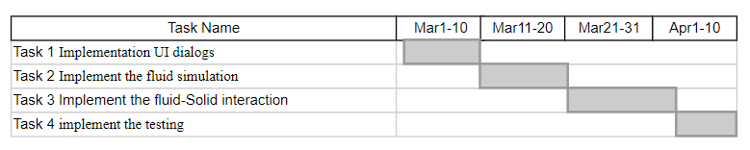

4. RELATED RESEARCH
In 1997, Gingold and Monaghan [1977] and Lucy introduced the SPH, which makes use of the Lagrangian description of fluid flow which automatically focuses attention on fluid elements. In their paper, they first give a detailed description of the smoothing method and establish conditions that guide the choice of the smoothing kernel.

There are two important improvements in the SPH, which are the free surface and the stiffness equation. Monaghan introduced the algorithm that adapts SPH to the free surface flow, and in 2003 Muller used a low stiffness equation of state along with surface tension and viscosity forces for interactive applications. In 2007, Becker and Teschner reduced compressibility with the stiffer “Tait Equation”, and introduced particle initialization with highly damped equations to reach a stable density near the surface.
In 2005, two-way SPH fluid interaction using “color field”-derived curvature was introduced by Muller. Colagrossi and Landrini more accurately captured velocity boundary conditions at solids by mirroring nearby fluid particles but were limited to simple solid geometry. In 2010, Ihmsen extrapolated fluid quantities into solid particles to improve solid boundary conditions, avoiding “stacking” and irregular pressure distributions in standing water situations.
In 1999, Fedkiw in their paper, Ghost Fluid Method, used extensively for Eulerian fluids, and also the ideas Lagrangian solids [Fedkiw 2002], inspires the author of the paper, Ghost SPH for Animating Water, extrapolate our velocity and density to ghost particles at both solid and free surface boundaries.

[Gingold and Monaghan, Lucy 1977] An early attempt before them, such as an alternative to the standard finite difference method was made by Pasta & Ulam(1959). They serve the continuous fluid as a fictitious set of particles with inter-particle forces designed to mimic the true pressure and other force. Compared with the SPH, the transport process of this method is difficult to include correctly. A better method is introduced is to make use of the Lagrangian description of fluid. The particles of fluid move according to the Newtonian equation with force and the central feature is that the force can be determined from the current position of the fluid elements. In their paper, they first gave a detailed description of the smoothing method and established conditions that guide the choice of the smoothing kernel. The technology gives satisfactory results for oscillating polytropes and for polytropes that relax from a non-spherical initial state to a spherical final state.

[Muller 2005]. In the previous work, the simulation only focuses on the animation of a single fluid. In the paper, Particle-Based Fluid-Fluid Interaction, the author, Matthias Müller, proposed a new particle-based method to simulate fluid-fluid interaction. The method consists of a set of extensions to the regular SPH method targeting the following phenomena:
Multiple fluids, global parameters in standard SPH-models are stored on individual particles, and equations would be expended to cope with additional particle attributes.
Trapped Air: Trapped air is simulated by generating air particles dynamically where air pockets are likely to be formed.
Phase transitions: according to temperatures, by changing the type of density of particles, the phenomenon of boiling water could be implemented.

[Solenthaler and Pajarola 2008] They study how to simulate the fluid interaction between miscible and immiscible liquids. The grid-based methods could have a good result in smooth effect and visually appealing surfaces, small-scale features on or below the scale of the underlying grid still can not be implemented. In SPH, particles have a spatial distance (smoothing length) over which their properties are smoothed by a kernel function. Authors modify the SPH formulation to correct for density problems, spurious and unphysical interface tension, and instabilities otherwise present at high-density contrast interfaces. By the modification of the formulation, the fluid with a high density ratio can be simulated more stably and the fluid behavior can be controlled according to the simulation problem of interest.

[Muller 2003] Based on Monaghan’s adaptations of SPH to free surfaces, Muller et al.’s main contributions are to derive the viscosity and pressure force fields directly from the Navier-Stokes equation and propose a way to model surface tension forces. Muller proposes the numerically stable and symmetric way to derive the pressure of a particle by multiplying the SPH smoothing kernel with the arithmetic mean with that of the neighbor particles. However, Muller et al. use the ideal gas equation for pressure, resulting in high compressibility which does not align with the characteristic of liquids. Similarly, the arithmetic difference is used to derive viscosity. As for surface tension, Muller shows that the gradient of the color field (1 at particle locations and 0 anywhere else) is the surface normal and can be used to compute the surface tension via a tension coefficient σ.

[Becker 2007] Becker et al.’s main step ahead from Muller’s work is to use the Tait equation (instead of the ideal gas equation) that enforces very-low-density variations (much stiffer) by neglecting atmospheric pressure that can simply be added as a constant pressure term. Tait equation results in more visually realistic animation and is efficient to compute. For a similar effect, for implementation, they employ a highly damped version of the momentum equation for initialization states of the particles. In this way, the particles can be more stable regarding density near the surface.

[Fedkiw 1999] Fedkiw et al. first proposed the ghost method as a coupling of Eulerian with Lagrangian methods for surface simulation where nonphysical oscillation (numerical smearing) near the surface can be reduced. Their main contribution is to define ghost cells (fluid particles close to the boundary are mirrored across the boundary). A ghost particle gets the same pressure, viscosity, mass, and density of its corresponding fluid particle while the normal component of the velocity is inverted.). Fedkiw et al. apply the isobaric (constant pressure) fix technique on ghost particles to keep the density profile from smearing out. This way maintains the robustness of the Eulerian scheme and is easy to program with simple extensions to multidimensional and multilevel time integration, e.g., Runge–Kutta methods. The use of ghost nodes provides the main framework for our authoring tool work to deal with surface artifacts.

5. RESULTS

5.1 Documentation/Tutorial

5.1.1 Document the workflow of your authoring tool.

0. (Optional) Customize the simulation parameters in “particles.cl”. Load the plugin under “RealSimNode / RealSimNode.py”
1. Import an arbitrary triangular mesh as a “.obj” file under the “mesh2pc” directory.
2. Select the mesh in Maya.
3. Click “RealSim / RealSim” on the menu bar to initiate the GPU-accelerated simulation task.
4. Now you get an animation, hit the play button. You can also:
1. Export the animation.
2. Bind materials and render with Arnold.
3. Or even adjust the number of particles in the “Display Percentage” setting of the “instancer”.
4. Adjust the size (scale), color, transparency, material, and a number of other useful properties of the particles in the setting of “pSphere1”.

5.1.2 Content Creation

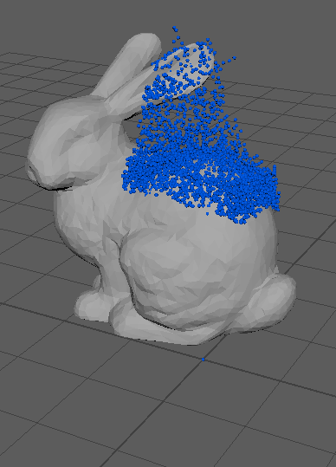
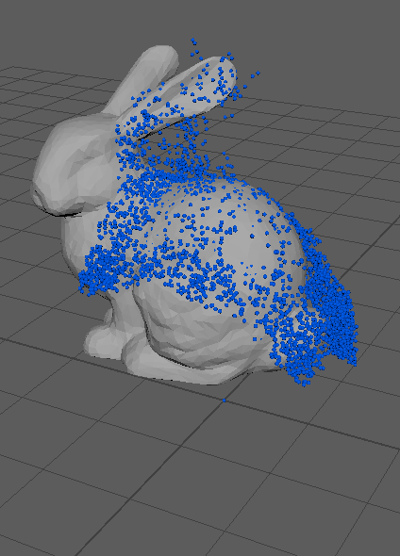
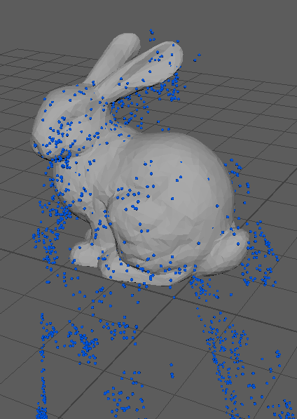

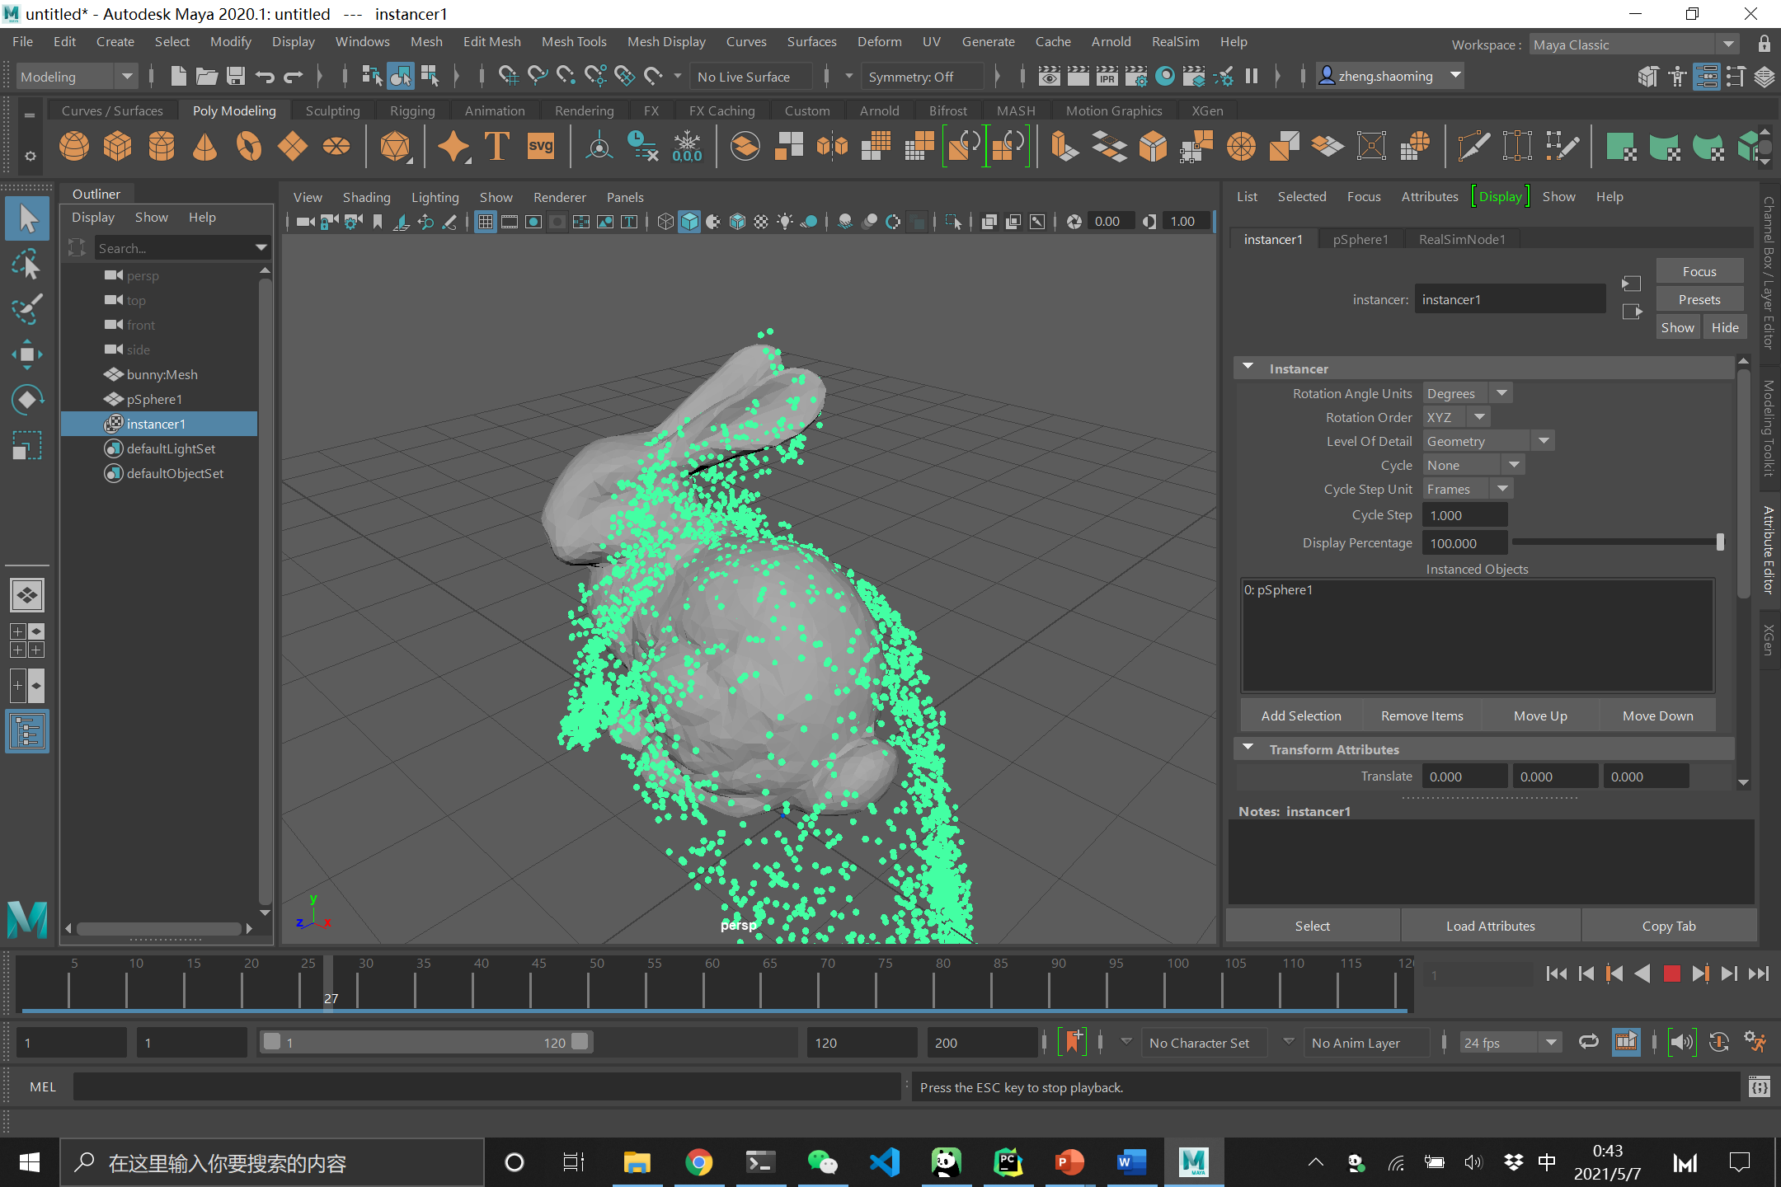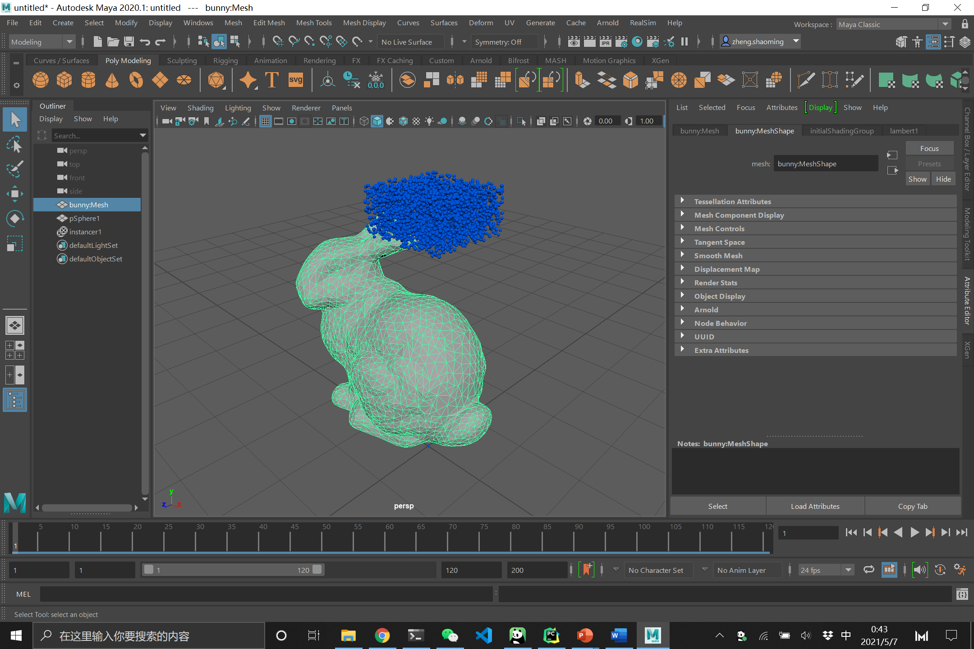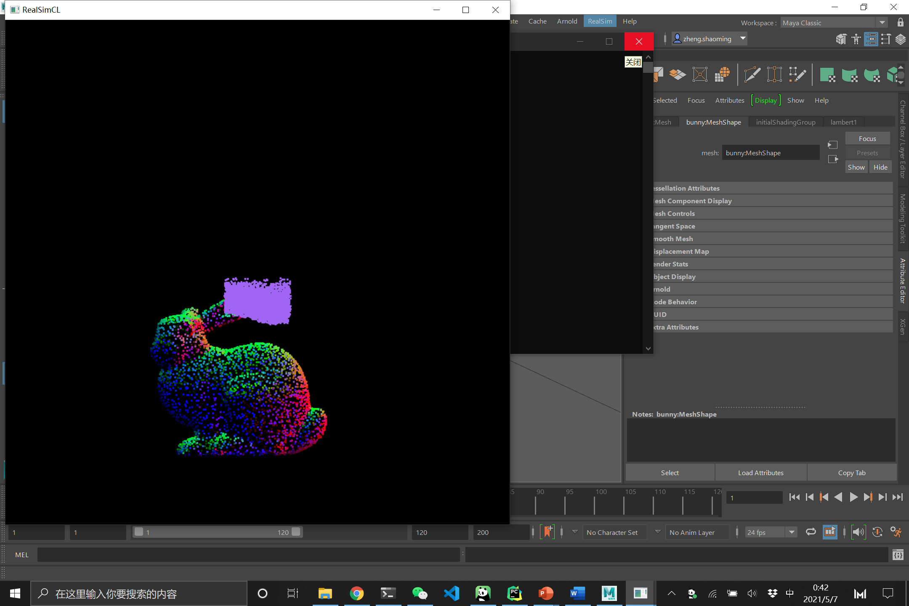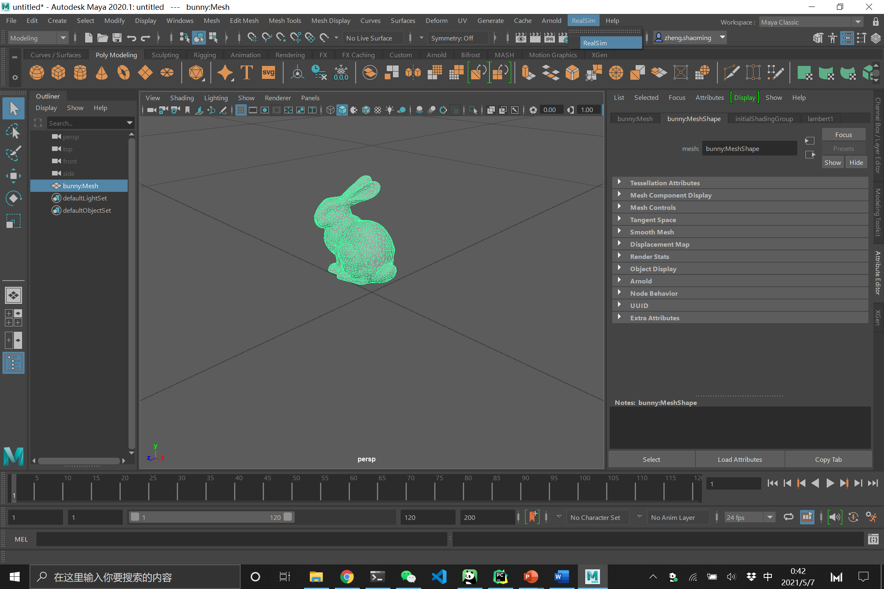

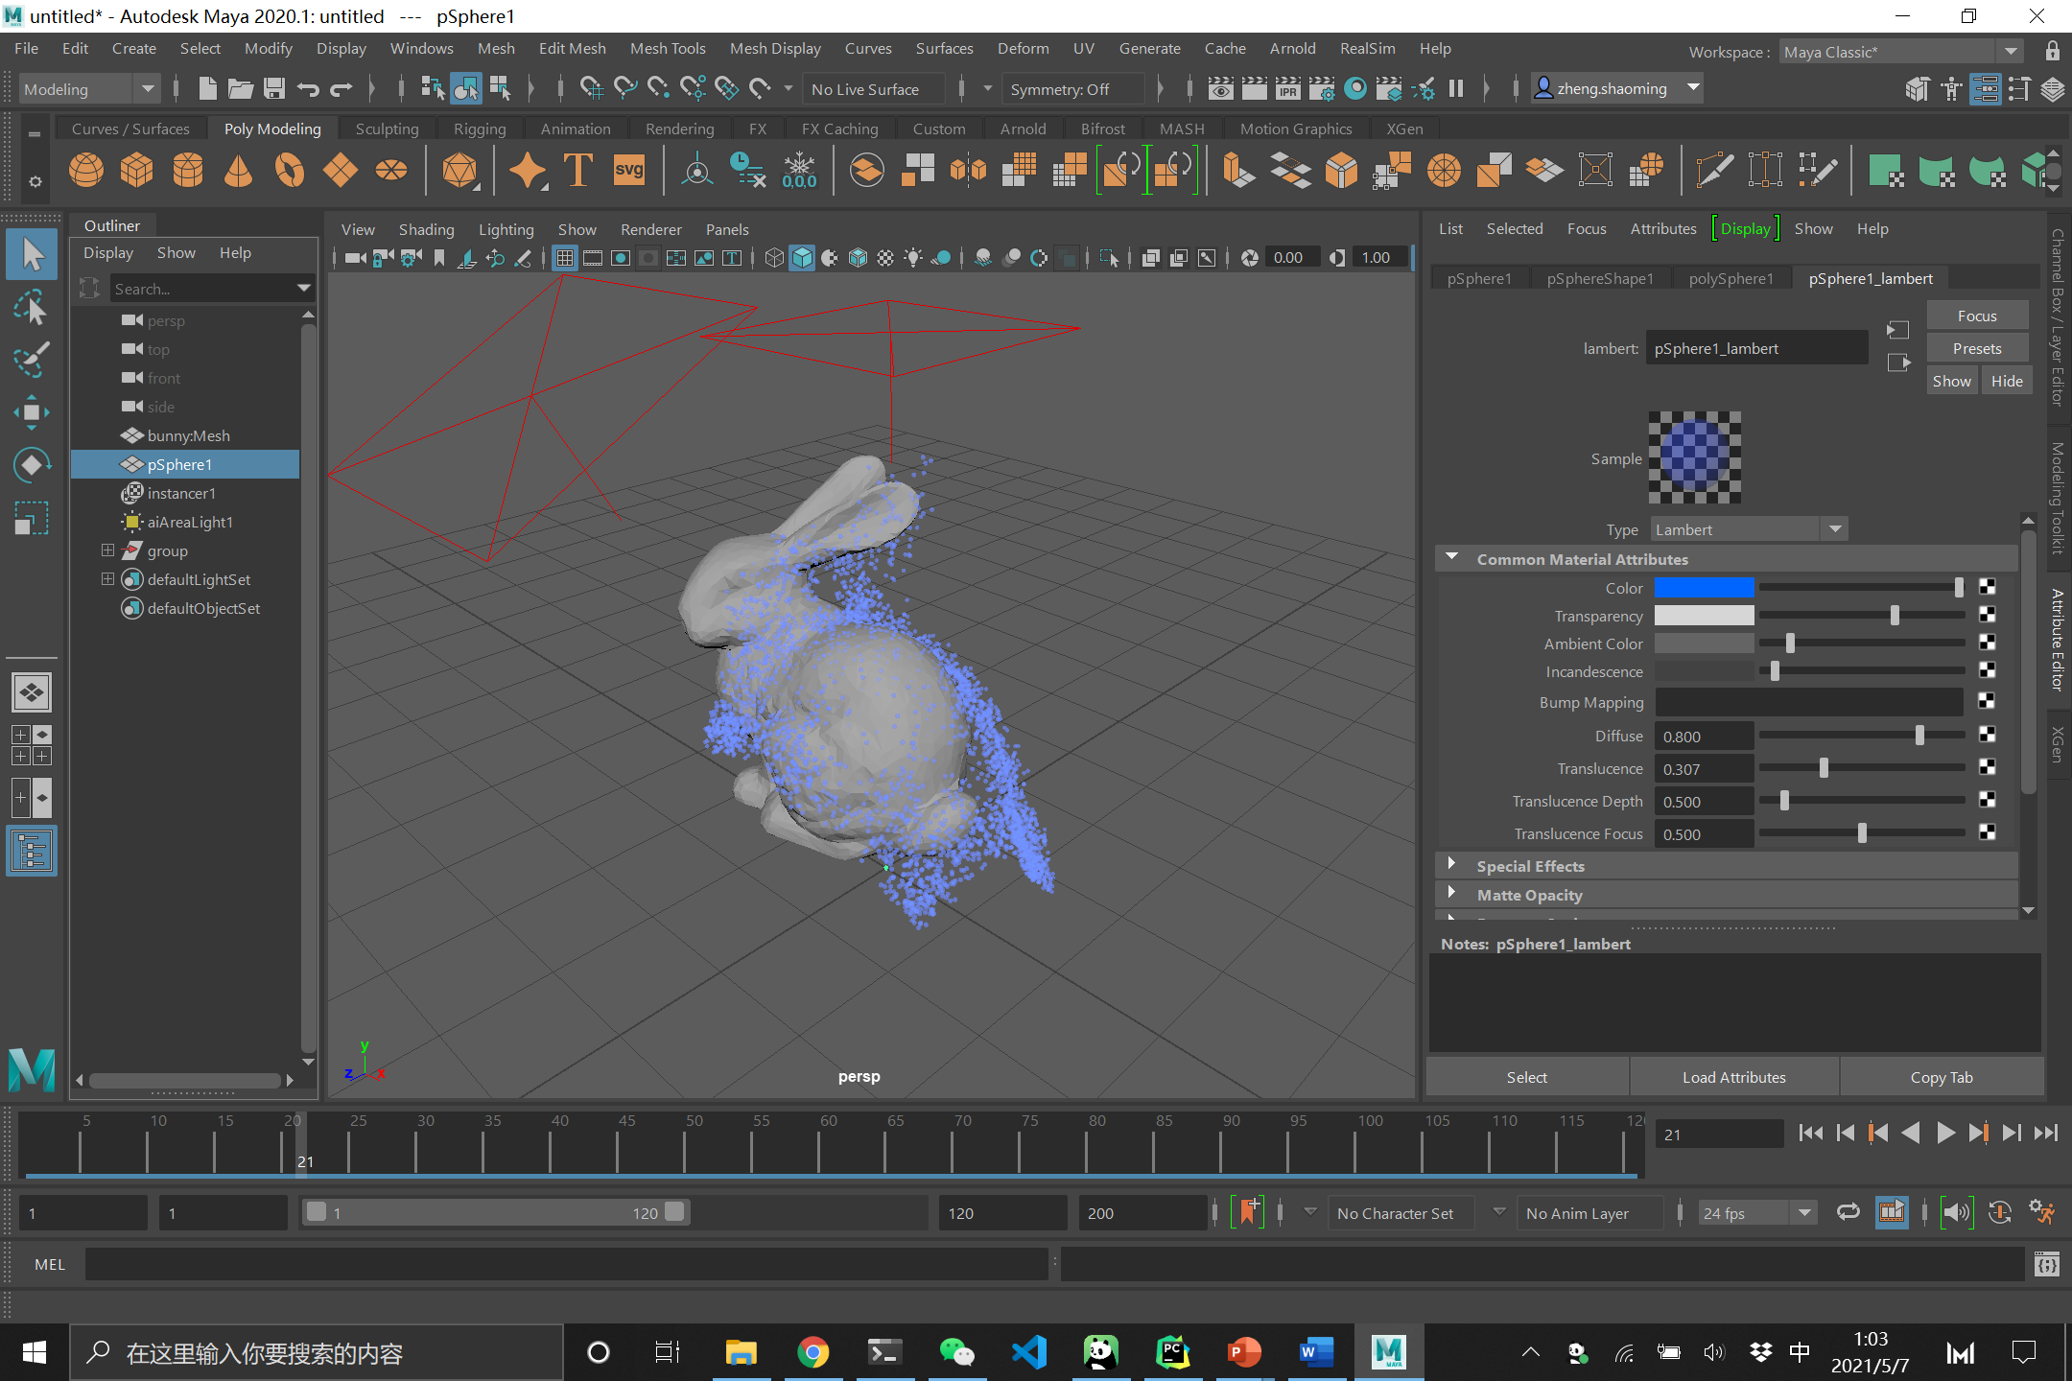

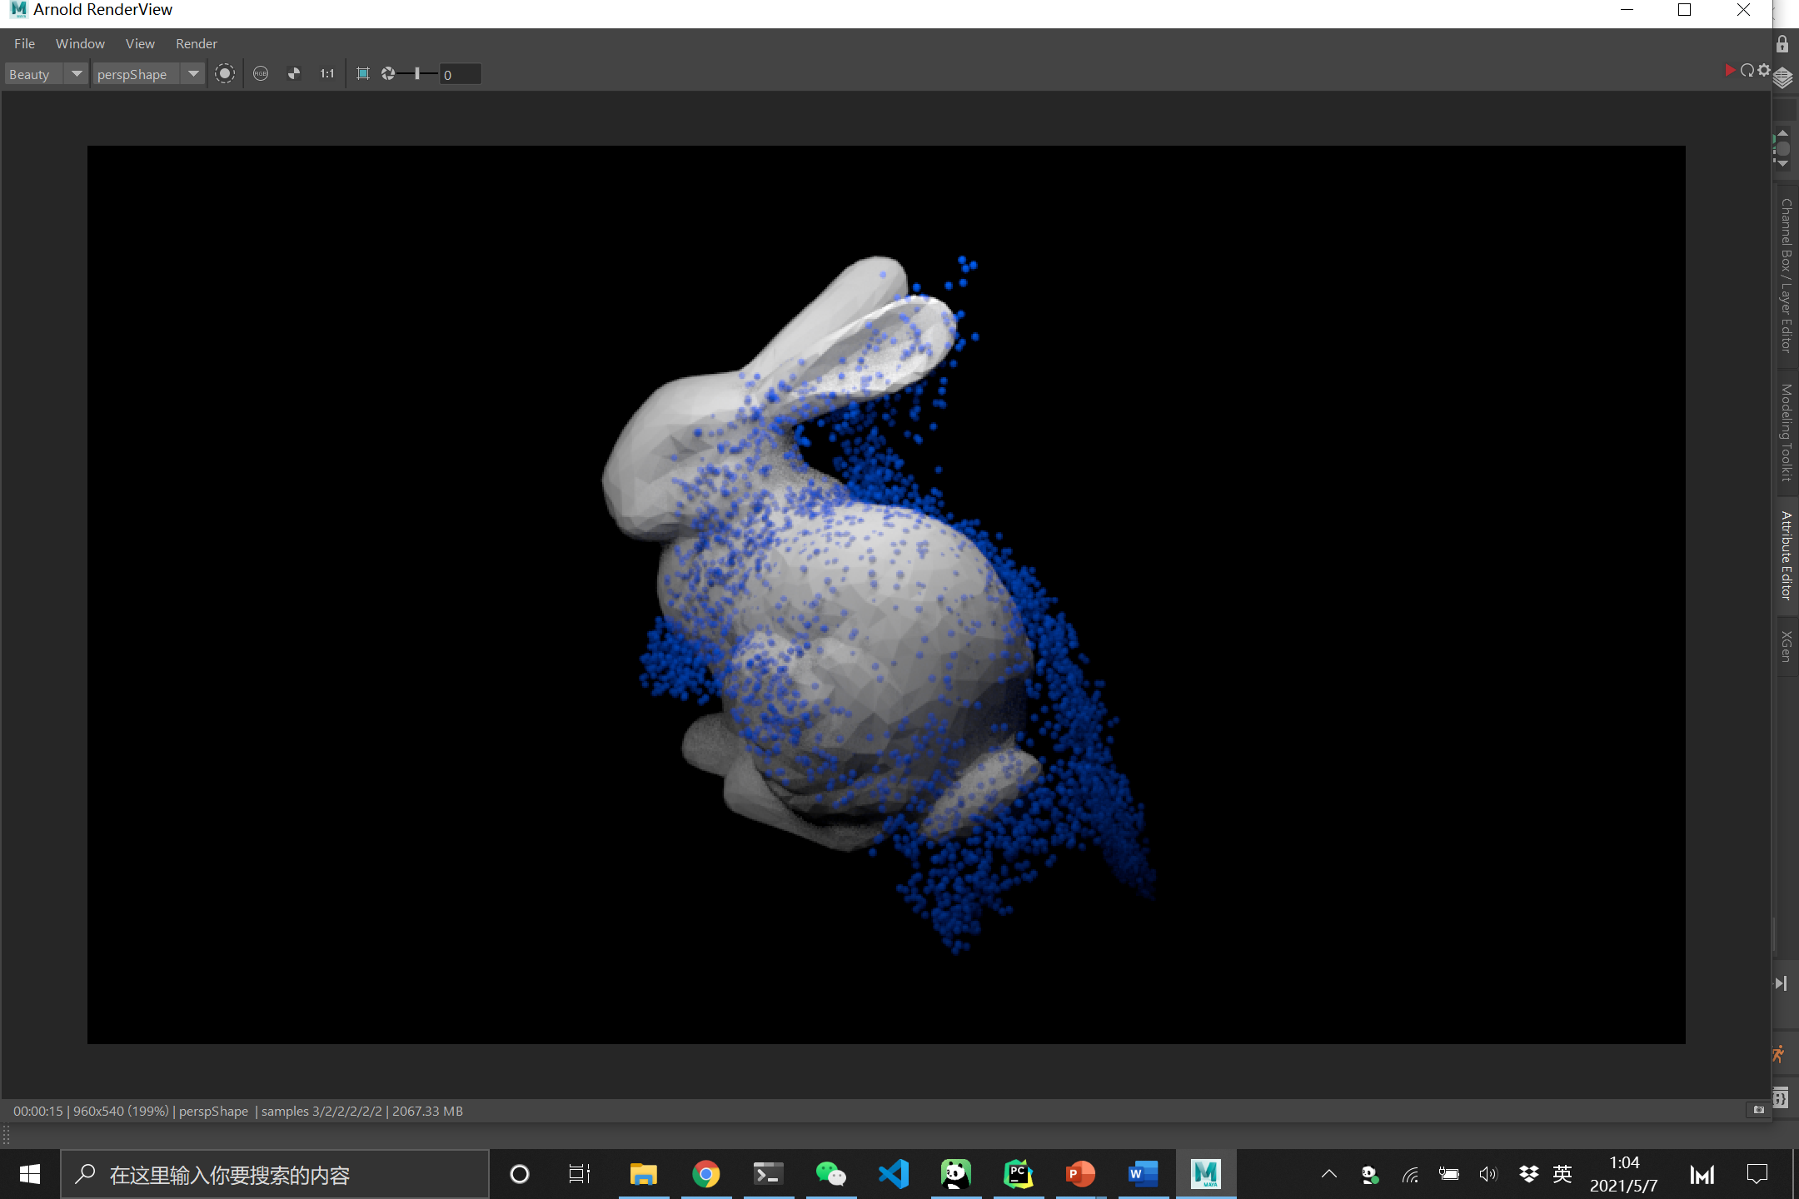

5.2 Discussion

5.2.1 Accomplishments
We have successfully implemented a Maya plug-in for fluid simulation based on physical simulation. Considering the complex geometric composition of the collision surface and the SPH is a simulation algorithm based entirely on the surface point cloud (particle) instead of mesh, I initially considered only realizing the simulation of liquid falling onto a few simple geometrical bodies, such as spheres. With the deepening of the research and the progress of the project, we found that we can transform complex geometry into a point cloud and find the normal of the position through open3d, to implement the simulation of different surface bodies by liquid. We input the vertices positions and normal data to the agent side, implement the parallel operation of the SPH algorithm with OpenCL through pre-calculation, and pass the results back to the authoring tool side through inter-Process Communication. According to the obtained data, we can achieve the results of each frame Animation. We have implemented the simulation of many particles by separating the front and back ends. Based on the above methods, we achieved the expected main features and added some new different surface bodies, such as Stanford’s bunny and cups, based on the original design.
What features were implemented?
- What worked?
- Loading an arbitrary mesh.
- Conversion from mesh to points cloud and get the normal vectors in each position.
- Implement the Ghost SPH on the agent side using the OpenCL and collect the data in GPU.
- Using the IPC to transfer the data to the Maya side.
- Animate each frame based on the obtained data.
- What did not work?
Make particles stay in a container.
- What features were not implemented? Why?
Allow arbitrary shape of the liquid. Because we assume that the user is more interested in the solid-fluid interaction while the liquid shape typically doesn’t matter.

5.2.2 Design Changes
- Were there any changes to the technical approach (i.e. way in which you planned to implement the tool)?
- What were they?
Changed the UI layout. We integrate particles number and individual properties control to instancer and sphere respectively.
- What prompted the design change?
This requires less effort in programming.

5.2.3 Total Man-Hours worked
· List the number of hours each group member spent working on the project. This should be the cumulative sum of hours listed in your weekly progress reports.
189 hours.

· Future Work
· What additional work is required to make what you have developed into a fully functional tool usable by an artist?
Enrich UI control such as allowing the user to select the shape of the liquid.

· Third-Party Software
· List ALL third-party and other software (with a brief description) used in your project that was not written by you. Also, please describe any source materials you reviewed that were provided or made available by the authors.

OpenCL & OpenGL: build the simulation. We first debug our code without visualization on C++ to guarantee a starter framework, then transfer to OpenCL with better color debugging.
Oregon State CIS-419 OpenGL display framework: the OpenGL viewport.
Open3D: convert an arbitrary triangular mesh into point cloud and normal vectors.
OpenMaya: build the Maya python node and animate each frame from the data.

We refer to the official documentations of the above tools.

5.3 Lessons Learned
· Please list anything you learned during your development efforts that you wish you had known in advance, such as Maya bugs, links to helpful Maya or Houdini documentation, useful third-party libraries, or other insights into using the Maya or Houdini APIs that would be helpful to students developing Maya or Houdini plugins in the future as a part of CIS660.

For the implementation of engineering projects, it is not a simple reproduction of the algorithm of the paper, but how to better meet the needs of users, and select better technologies based on such needs and use their advantages to implement the tool. In the early stages of the project, we spent more effort on the implementation of the SPH algorithm, while neglecting how to achieve the collaboration between the algorithm and Maya. We hope to use OpenCL (C++)-based parallel operations for data calculation, but we cannot achieve synchronous data reading in Maya. At the same time, Maya cannot convert the mesh into a point cloud, to obtain the point cloud position and normal required by the SPH algorithm. Based on constant exploration and constant experimentation of new methods and technologies, we finally solved the above problems. We believe that the biggest problem in implementing the Maya plug-in might be how to integrate the code and third-party libraries into Maya. We know that Maya is a good modeling software, but it does not have an open development environment and cannot achieve parallel computing and data processing. Therefore, there will be certain restrictions when we are adding new features. We need to make good solutions to these problems in advance. From this project, the problem with reflection is that we did not design this project from a macro perspective but adopted an agile development model. We need to do a good job of investigation in advance and build a basic framework to implement basic features and improve the final product under this framework.

